REPORT
OF
AICTE | IBM SKILLSBUILD ACADEMIC INTERNSHIP – DATA ANALYTICS WITH AI
Submitted To
Ms. Surabhi Purwar
School of Computer Science and Engineering
IILM University, Greater Noida, U.P.
In partial fulfilment of the requirement of degree of
B.Tech CSE

By
Roll Number of Student: CS-23411341
Name of Student: KAUSHLENDRA KUMAR DWIVEDI

Batch: 2023–2027

CANDIDATE’S DECLARATION
I, KAUSHLENDRA KUMAR DWIVEDI , do hereby declare that the internship report titled “AICTE | IBM SkillsBuild Academic Internship – Data Analytics with AI” has been completed by me to fulfil the requirement for the award of the degree of Bachelor of Technology in CSE. All the references have been quoted and I have not taken as such any material from any other source. I affirm that this report is my own and has not been submitted to any other institute for any degree/diploma requirement and further I shall be solely responsible for any kind of copyright violation in this regard.
Signature: __________________________
Student Name: KAUSHLENDRA KUMAR DWIVEDI
Roll No.: CS-23411341

ACKNOWLEDGEMENT
I am using this opportunity to express my gratitude to everyone who supported me throughout the Internship Program. I am thankful for their aspiring guidance, invaluably constructive criticism and friendly advice during this work. I am sincerely grateful to them for sharing their truthful and illuminating views on a number of issues related to this work.
I express my gratitude to my parents for their blessings.
Signature: __________________________
Student Name: KAUSHLENDRA KUMAR DWIVEDI
Roll No.: CS-23411341

TABLE OF CONTENTS

Chapter No. | Chapter Name | Page Nos.
 | Cover Page
1. | Candidate’s Declaration | i
2. | Acknowledgment | ii
3. | Table of content | iii
 | Internship Completion Certificate
4. | Project Description  4 .1 Introduction  4.2 Organization Profile  4.3 Problem Statement  4.4 Project Objectives  4.5 Scope of the Project  4.6 Technologies and Tools Used  4.7 System Architecture  4.8 Methodology  4.9 Expected Outcomes  4.10 Certificates of completion and other communication mail proof must be attached | 1  2  3  4  5  6  7  8 -9  9  10-11
5. | Bibliography/References | iv

INTERNSHIP COMPLETION CERTIFICATE
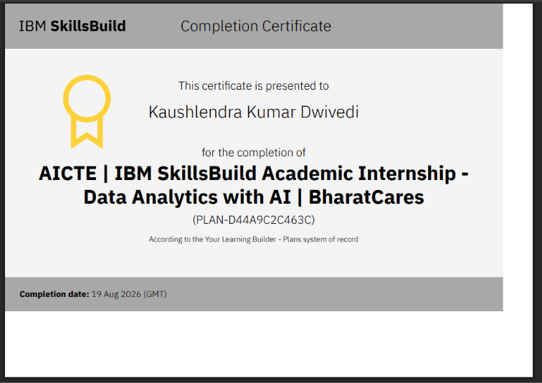

4. PROJECT DESCRIPTION

4.1 Introduction
The AICTE–BharatCares–IBM SkillsBuild Academic Internship in Data Analytics with AI provided me with an opportunity to gain practical exposure to the fundamentals of data analytics, artificial intelligence, and machine learning. The six-week virtual internship was designed to complement academic learning with practical, industry-oriented knowledge and project-based activities. The internship was scheduled from 17 August 2026 to 30 December 2026.
During the internship, I developed an understanding of the different stages involved in the data analytics process, starting with data cleaning, data wrangling, and preprocessing, followed by Exploratory Data Analysis (EDA). These activities helped me understand how raw data can be prepared, examined, and interpreted to identify useful patterns and insights.
The internship also introduced me to predictive analytics and machine learning concepts, including supervised learning, regression, classification, and decision trees. In addition, I learned about unsupervised learning, clustering, data visualization, and AI-driven insights, which helped me understand how analytical techniques can be used to support data-driven decision-making.
Along with technical learning, the internship included weekly masterclasses, guided mentorship, and a final project, providing an opportunity to apply the concepts learned during the program in a practical context. The experience helped me connect theoretical concepts from my academic studies with practical applications in Data Analytics and AI.
Overall, this internship served as a valuable learning experience that strengthened my understanding of data analysis, machine learning, AI concepts, analytical thinking, and problem-solving, while also giving me greater confidence in approaching real-world data-related problems.
This version is based on the actual structure and learning areas in your offer letter, rather than your friend's MERN/School ERP content. Your offer letter confirms the six-week virtual format and the 17 August–30 December 2026 schedule. It also confirms the data cleaning, EDA, predictive analytics, ML, visualization, AI-insight, and final-project components

4.2 Organization Profile

BharatCares is the organization through which I undertook the AICTE | IBM SkillsBuild Academic Internship in Data Analytics with AI. The internship was conducted in collaboration with AICTE and IBM SkillsBuild and focused on developing foundational knowledge and practical understanding of Data Analytics, Artificial Intelligence, and Machine Learning.
The internship provided an opportunity to understand how data can be prepared, analyzed, and transformed into meaningful insights. The learning activities covered important stages of the data analytics process, including data cleaning, data wrangling, data preprocessing, and Exploratory Data Analysis (EDA). These topics helped me understand the importance of working with structured and reliable data before performing further analysis.
The program also introduced various concepts related to predictive analytics and machine learning. These included supervised learning, regression, classification, and decision trees. Further learning covered unsupervised learning, clustering, data visualization, and AI-driven insights, providing exposure to different approaches for analyzing data and supporting data-driven decision-making.
The internship followed a six-week virtual learning structure, including weekly masterclasses, IBM SkillsBuild learning activities, guided learning, and a final project. The program was scheduled from 17 August 2026 to 30 December 2026.
Company / Internship Details
- Organization: BharatCares
- Internship Program: AICTE | IBM SkillsBuild Academic Internship – Data Analytics with AI
- Role: Data Analytics with AI Intern
- Internship ID: IBMUEDA1101
- Duration: 17 August 2026 – 30 December 2026
- Mode: Virtual
- Collaborating Organizations: AICTE and IBM SkillsBuild

4.3 Problem Statement

Data Analytics projects involve working with raw and often unstructured data, which can make it difficult to obtain meaningful information without proper preparation and analysis. During the internship, I was introduced to the importance of systematically handling data through different stages of the analytics process.
A major challenge was understanding how raw data can be cleaned, transformed, and prepared for further analysis. Data cleaning, wrangling, and preprocessing were therefore important parts of the learning process, as they help improve the quality and usability of data before applying analytical techniques.
Another challenge was learning how to explore and understand data effectively. Exploratory Data Analysis (EDA) was covered to understand patterns, relationships, and useful information within datasets. This helped develop a structured approach to examining data before moving toward predictive analysis.
The internship also addressed the challenge of using analytical techniques for prediction and decision-making. The learning program introduced predictive analytics, supervised learning, regression, classification, and decision trees, providing an understanding of how machine learning techniques can be applied to analytical problems.
.

4.4 Project Objectives
The primary objectives of the Data Analytics with AI internship were:
- To gain practical knowledge of Data Analytics, Artificial Intelligence, and Machine Learning through structured learning activities.
- To understand the complete data analytics workflow, from data preparation and exploration to analysis, visualization, and insight generation.
- To develop an understanding of data cleaning, data wrangling, and data preprocessing techniques for preparing data for analysis.
- To learn and apply the concepts of Exploratory Data Analysis (EDA) to identify patterns, relationships, and useful information from data.
- To understand predictive analytics and predictive modeling and their role in making data-driven predictions.
- To gain foundational knowledge of supervised machine learning, including regression, classification, and decision-tree techniques.
- To understand unsupervised learning and clustering techniques for identifying patterns and groups within data.
- To develop an understanding of data visualization and learn how visual representations can communicate analytical findings effectively.
- To understand the role of AI-driven insights in extracting useful information from data and supporting data-driven decision-making.
- To apply the concepts learned during the internship through a final project and improve analytical thinking, problem-solving, critical thinking, and professional skills.

4.5 Scope of the Project

The scope of the internship covered the fundamentals of Data Analytics, Artificial Intelligence, and Machine Learning, with a focus on understanding how data can be prepared, analyzed, modeled, visualized, and converted into meaningful insights.
The technical scope included data cleaning, data wrangling, data preprocessing, Exploratory Data Analysis (EDA), statistical analysis, predictive analytics, and predictive modeling. The internship also introduced important machine learning concepts such as supervised learning, regression, classification, decision trees, unsupervised learning, and clustering.
Another important part of the scope was data visualization and AI-driven insights. The learning activities provided an understanding of how analytical results can be represented visually and how AI-based techniques can help generate useful insights from data. Power BI and Tableau were also covered as part of the visualization learning activities.
The internship also included a project-based component, where the concepts learned throughout the program could be connected and applied to a practical problem. The final project involved project development, completion, submission, and presentation as part of the internship requirements.
The overall scope therefore extended beyond theoretical learning and included practical understanding, analytical thinking, problem-solving, and project development. The internship provided a structured foundation for understanding how Data Analytics and AI can be used to examine data, identify patterns, develop predictions, visualize findings, and support data-driven decision-making.

4.6 Technologies and Tools Used
The internship focused primarily on understanding Data Analytics, Artificial Intelligence, and Machine Learning concepts. The major technologies, techniques, and tools covered during the internship were:
- Data Cleaning – Used as an important step for identifying and handling issues in raw data before analysis.
- Data Wrangling – Covered techniques for transforming and organizing data into a suitable format for analysis.
- Data Preprocessing – Used to prepare data for further analytical and machine learning tasks.
- Exploratory Data Analysis (EDA) – Used to examine datasets, identify patterns, understand relationships, and generate initial insights.
- Statistical Analysis – Introduced as a method for understanding data and supporting analytical conclusions.
- Predictive Analytics – Covered techniques for using available data to make predictions and support data-driven decisions.
- Predictive Modeling – Introduced as part of the learning process for developing models based on historical data.
- Supervised Learning – Covered as a fundamental machine learning approach using labeled data for prediction and classification tasks.
- Regression – Introduced as a machine learning technique for predicting numerical outcomes.
- Classification – Covered for understanding how data can be categorized into different classes.
- Decision Trees – Introduced as a supervised learning technique for making predictions through decision-based structures.
- Unsupervised Learning – Covered for identifying patterns and structures in data without predefined labels.
- Clustering – Introduced as an unsupervised learning technique for grouping similar data points.
- Data Visualization – Covered for representing analytical results in a clear and understandable visual form.
- Power BI and Tableau – Introduced as visualization tools during the internship's learning activities.
- AI-Driven Insights – Covered to understand how AI techniques can assist in extracting meaningful information and insights from data.
- IBM SkillsBuild – Used as the learning platform for the internship's structured learning activities and learning plan.
- Project Development and Presentation – The internship included a final project through which the concepts covered during the program could be applied and presented as part of the completion requirements.

4.7 System Architecture
he Data Analytics with AI internship followed a structured learning approach rather than a traditional software system architecture. The overall process focused on understanding how raw data can be transformed into meaningful information through different stages of data analytics and machine learning.
The logical workflow followed during the internship can be represented as:
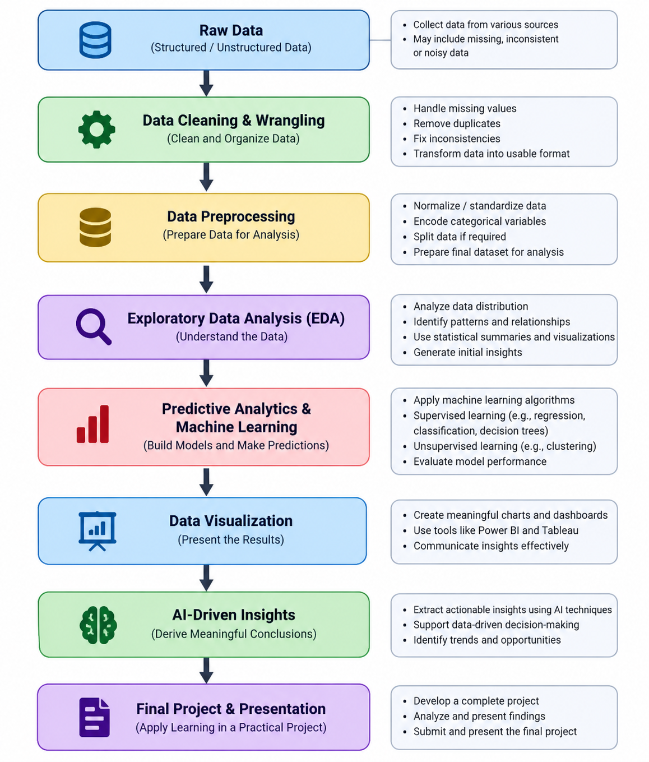

The first stage involved data cleaning, wrangling, and preprocessing, where the importance of preparing data before analysis was studied. This was followed by Exploratory Data Analysis (EDA) to understand patterns, relationships, and useful information within the data.
After data exploration, the learning process moved toward predictive analytics and machine learning. The internship covered supervised learning concepts such as regression, classification, and decision trees, along with unsupervised learning and clustering.
The next stage focused on data visualization and AI-driven insights. Visualization techniques help present analytical findings in an understandable form, while AI-driven approaches can be used to derive meaningful insights from data. Power BI and Tableau were also included in the internship's learning activities.

4.8 Methodology

The internship followed a structured, learning-oriented methodology covering Data Analytics, AI, and Machine Learning.
4.8.1 Foundation Learning
Started with orientation, IBM SkillsBuild learning, and basic Data Analytics concepts.
4.8.2 Data Preparation & Analysis
Covered data cleaning, wrangling, preprocessing, and Exploratory Data Analysis (EDA) to understand and analyze data.
4.8.3 Predictive Analytics & ML
Learned predictive analytics, supervised learning, regression, classification, decision trees, clustering, and unsupervised learning.
4.8.4 Visualization & AI Insights
Covered data visualization, Power BI, Tableau, and AI-driven insights to communicate analytical findings.
4.8.5 Final Project
Applied the concepts through a final project, followed by submission and presentation.

4.9 Expected Outcomes
The internship was expected to provide practical and conceptual understanding of Data Analytics, Artificial Intelligence, and Machine Learning. The major expected outcomes were:
- Understanding of Data Analytics
Develop a clear understanding of the data analytics process and how data can be transformed into meaningful information and insights.
- Data Preparation Skills
Gain knowledge of data cleaning, data wrangling, and data preprocessing, including techniques for preparing data before analysis.
- Exploratory Data Analysis
Understand EDA and learn how to examine data, identify patterns and relationships, and generate initial insights.
- Predictive Analytics Knowledge
Develop an understanding of predictive analytics and predictive modeling and how they can be used to make data-driven predictions.
- Machine Learning Foundation
Gain foundational knowledge of supervised learning, regression, classification, decision trees, unsupervised learning, and clustering.
- Data Visualization Skills
Understand how analytical results can be presented through effective visualizations and gain exposure to Power BI and Tableau.
- AI-Driven Insights
Understand how AI-based approaches can help extract useful insights from data and support data-driven decision-making.
- Practical Project Experience
Apply the concepts learned during the internship through a final project, including project development, submission, and presentation.
- Analytical and Problem-Solving Skills
Improve analytical thinking, critical thinking, problem-solving, and decision-making abilities through practical learning activities.
- Professional Development
Gain experience in structured learning, guided mentorship, project completion, and presentation, helping connect academic concepts with practical applications.

4.10 Certificates of Completion and Communication Proof

The Internship Completion Certificate issued by BharatCares is attached as supporting evidence of the internship. The certificate recognizes Kaushlendra Kumar Dwivedi for successfully completing the AICTE | IBM SkillsBuild Academic Internship – Data Analytics with AI. The certificate records the completion date as 19 August 2026 (GMT).
The internship offer letter is also included as supporting documentation. It confirms the student's selection for the Virtual IBM SkillsBuild Data Analytics with AI Internship 2026, conducted in collaboration with AICTE, with the scheduled internship period from 17 August 2026 to 30 December 2026.
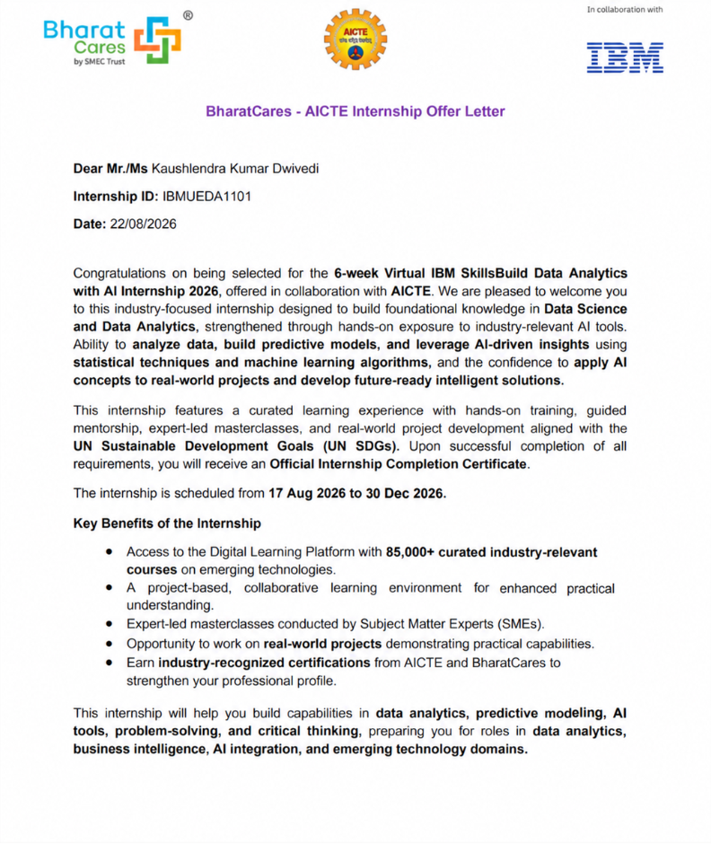

5. BIBLIOGRAPHY / REFERENCES
- BharatCares, “AICTE | IBM SkillsBuild Academic Internship – Data Analytics with AI,” Internship Offer Letter, dated 22 August 2026.
- BharatCares, “AICTE | IBM SkillsBuild Academic Internship – Data Analytics with AI,” Internship Completion Certificate, dated 19 August 2026.
- IBM SkillsBuild, “Data Analytics with AI,” Learning Plan and Internship Learning Resources.
- AICTE, “AICTE Internship Program,” Internship-related guidelines and program information.
- IILM University, School of Computer Science and Engineering, “Internship Report Format.”
- IBM SkillsBuild, “Data Analytics,” learning resources covering data preparation, analysis, machine learning, and AI.
- Power BI, “Data Visualization and Business Intelligence,” learning resources referenced during the internship.
- Tableau, “Data Visualization,” learning resources referenced during the internship.
- OpenAI, “ChatGPT,” used as an AI-assisted learning and writing support tool where applicable.
- BharatCares / AICTE / IBM SkillsBuild, Internship masterclasses, guided learning materials, and project-related resources.

